Angle of Support – Possession / Passing

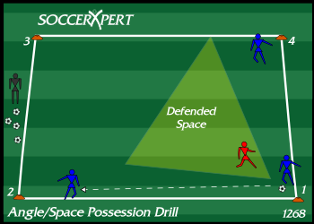
Drill Objective:
The Angle of Support Soccer Possession Drill is a soccer passing drill for teaching young players angle of support and spacing.

Drill Setup:
- Create a grid that is 10 X 10 yards.
- Organize the team into groups of three players per grid.
- Each of the three players should position themselves near three different corners of the grid with one ball.

Drill Instructions:
- The instructions are merely to never leave an empty cone adjacent to the player with the ball.
- For example, if the drill begins with a player at position 1 in possession of the ball, then players should be at position 2 and 4 (cones adjacent to the player in possession of the ball).
- The player at position 1 can pass to either of the players at positions 2 and 4.
- If the player at position 1 passes to the player at position 2, the player at position 4 must quickly move to position 3 to support the player in “un-defended space.”
- The play continues with no defensive pressure and players are allowed to pass to either supporting player.
- This soccer drill is simple, but players will have to pay attention to the ball movement and anticipate the next move to move to space quicker.

Drill Coaching Points:
- Make sure players are thinking and moving quickly to the next supporting position.
- Explain Defended Space (see diagram)
- Help players with good angle of support

Drill Variations
- Play in 1 or 2 touches.
- Add a passive defender (this could be a coach or parent).
- Add an active defender to simulate real pressure in the game.

